Лабораторное занятие № 26-27.
Рекурсия
Выполнил Дацук
4 вариант

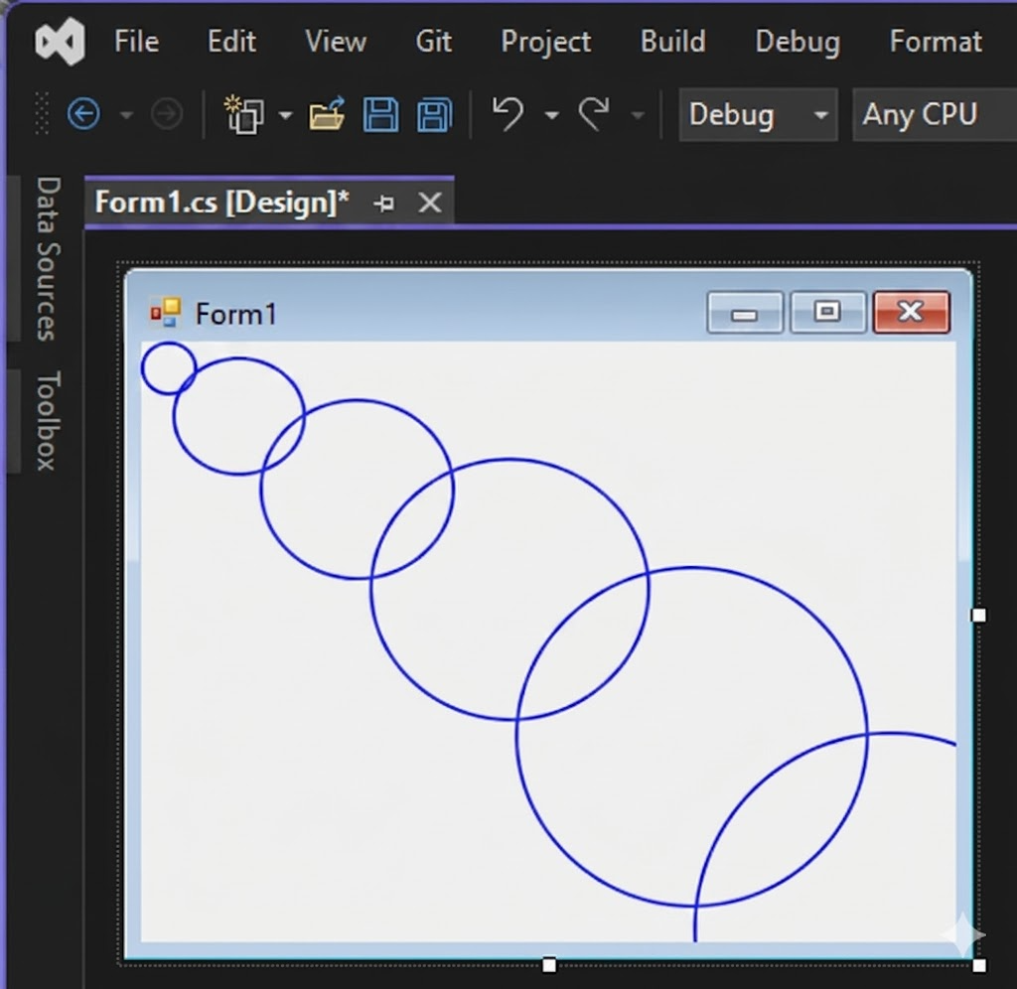
private void DrawSpiralCircles(Graphics g, int N, double angle, double step)
{
if (N <= 0) return;

double k = 15;
double r = k * angle;

// Центр формы
int centerX = ClientSize.Width / 2;
int centerY = ClientSize.Height / 2;

int x = centerX + (int)(r * Math.Cos(angle));
int y = centerY + (int)(r * Math.Sin(angle));

int diameter = 20 + (int)(angle * 2);

g.DrawEllipse(new Pen(Color.Blue, 2), x - diameter / 2, y - diameter / 2, diameter, diameter);

Wait(300);

DrawSpiralCircles(g, N - 1, angle + step, step);
}

private void Form1_Paint(object sender, PaintEventArgs e)
{
Graphics g = e.Graphics;
g.SmoothingMode = System.Drawing.Drawing2D.SmoothingMode.AntiAlias;

DrawSpiralCircles(g, 20, 0.5, 0.6);
}

